Practical Week 3: Iteration 1 Report
Project Management System

1. Objective
The objective of Practical Week 3 was to review the planned user stories for Iteration 1, create a simple project board, allocate Milestone 1 user stories into three iterations, monitor Iteration 1 using Todo / In Progress / Done labels, implement at least two Iteration 1 user stories, and draw a burn down graph.

2. Project Background
The Project Management System is designed to help teams manage tasks, deadlines, responsibilities, progress, and communication. The planned features include creating and managing tasks, assigning tasks, updating status, monitoring deadlines, tracking project progress, and improving communication.

3. User Stories Used for Milestone 1
No. | Target Users | Title | Short Description | Priority | Estimate
1 | Student Team Members | View My Assigned Tasks | Users can view their tasks, task status, and deadline information in one place. | 10 | 5 days
2 | Student Team Members | Add New Tasks | Users can add new tasks for project work with basic task details. | 20 | 3 days
3 | Student Team Members | Edit Task Information | Users can edit task information when project requirements or task details change. | 20 | 3 days
4 | Project Managers | Assign Team Tasks | Managers can clearly assign tasks to team members. | 10 | 5 days
5 | Project Managers | Track Project Progress | Managers can view overall project progress and check which tasks are completed or unfinished. | 20 | 4 days
6 | Project Managers | Identify Delayed Tasks | Managers can identify unfinished or delayed tasks so that project problems can be noticed earlier. | 20 | 4 days
7 | Workplace Team Members | Remove Completed Tasks | Users can remove unnecessary or completed tasks to keep the task list clear and organized. | 30 | 2 days
8 | Workplace Team Members | Share Task Updates | Users can add brief updates to tasks to reduce redundant information in communication. | 30 | 3 days

4. Milestone 1 Iteration Allocation
The user stories were allocated into three iterations based on priority and estimated effort. Higher priority items were placed earlier, while communication and cleanup features were placed later.

Iteration 1
Target Users | Title | Priority | Estimate | Status
Student Team Members | View My Assigned Tasks | 10 | 5 days | Done
Project Managers | Assign Team Tasks | 10 | 5 days | Todo
Student Team Members | Add New Tasks | 20 | 3 days | Done
Total estimate: 13 days

Iteration 2
Target Users | Title | Priority | Estimate | Status
Student Team Members | Edit Task Information | 20 | 3 days | Todo
Project Managers | Track Project Progress | 20 | 4 days | Todo
Project Managers | Identify Delayed Tasks | 20 | 4 days | Todo
Total estimate: 11 days

Iteration 3
Target Users | Title | Priority | Estimate | Status
Workplace Team Members | Share Task Updates | 30 | 3 days | Todo
Workplace Team Members | Remove Completed Tasks | 30 | 2 days | Todo
Total estimate: 5 days

5. Iteration 1 Project Board
A simple GitHub project board can be represented using a folder or Markdown board with three labels: Todo, In Progress, and Done.

Initial Board
Status | Target Users | Title | Priority | Estimate
Todo | Student Team Members | View My Assigned Tasks | 10 | 5 days
Todo | Student Team Members | Add New Tasks | 20 | 3 days
Todo | Project Managers | Assign Team Tasks | 10 | 5 days

Current Board After Practical Class
Status | Target Users | Title | Priority | Estimate | Notes
Done | Student Team Members | View My Assigned Tasks | 10 | 5 days | Implemented in the prototype. Users can view all tasks or filter assigned tasks.
Done | Student Team Members | Add New Tasks | 20 | 3 days | Implemented in the prototype. Users can add a task with title, description, deadline, and default status.
Todo | Project Managers | Assign Team Tasks | 10 | 5 days | Planned for completion later in Iteration 1.

6. Implementation Completed
At least two user stories from Iteration 1 were implemented during the practical class.
Implemented User Story | Files | Implemented Behaviour | Status
View My Assigned Tasks | src/index.html, src/app.js, src/style.css | The user can view a task list and filter tasks assigned to the selected user. | Done
Add New Tasks | src/index.html, src/app.js, src/style.css | The user can add a new task with title, short description, deadline, and default status. The task is saved in browser local storage. | Done

7. Burn Down Graph for Iteration 1
Total planned effort for Iteration 1 was 13 days. After implementing two user stories, 8 days of estimated work were completed and 5 days remained.
Day / Step | Completed Work | Remaining Work
Start | 0 days | 13 days
After board setup | 0 days | 13 days
After Add New Tasks completed | 3 days | 10 days
After View My Assigned Tasks completed | 8 days | 5 days
End of practical class | 8 days | 5 days
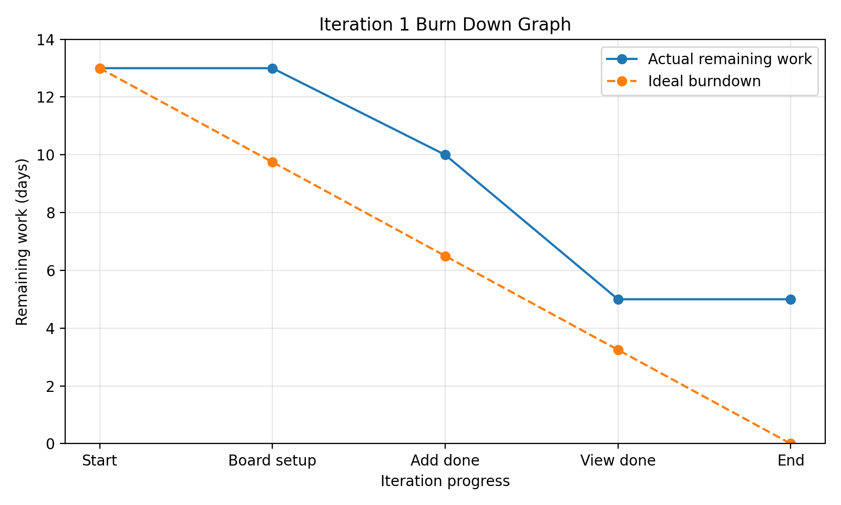

8. Suggested GitHub Folder / Board Structure
iteration-1/
iteration1_project_board.md
milestone1_iteration_plan.md
burndown_data.md
docs/burndown_graph.png
src/index.html
src/style.css
src/app.js

9. Conclusion
For Practical Week 3, the team reviewed the planned user stories, allocated the Milestone 1 work into three iterations, created a simple Iteration 1 project board, marked the Iteration 1 user stories as Todo initially, updated the board after implementation, completed two Iteration 1 user stories, and produced a burn down graph to monitor remaining work.

References Used
- W1 Project Management System document: project objective, features, and initial backlog ideas.
- W2 User Stories document: target users, interview results, user stories, priorities, and estimates.
- Head First Chapter 3 Project Planning PDF: prioritisation, iteration planning, project boards, and burn down planning concepts.

